Customer NameDocument Title

INTERNAL
: Resorts World at Sentosa Pte. Ltd.

RWS
TECHNICAL SPECIFICATION – INTERFACE

S2P-I-027 TS for GRN interface Sub-system to S4H

Contents
1 Document Organization 5
1.0 Document Log 5
1.1 Integration, Document Reference 5
2 Clean Core Compliance 6
3 Program Attributes 6
3.1 Selection Parameter / Filter 7
3.2 Validation 7
3.2.1 Selection Criteria validations 7
3.2.2 Interface parameter validations 7
3.2.3 Other validations 7
3.3 Authorization Requirements 8
3.4 Definition 8
3.5 Defined Fields 8
3.6 Procedure 8
3.7 Technical Flow Diagram 8
3.8 Processing Logic 8
3.8.1 Validation 8
3.8.2 Mapping 8
3.8.3 Error Handling 8
3.8.4 Custom DDIC Objects 8
3.8.5 Custom CDS View Entity Details 8
3.8.6 BRF+ Design 9
3.9 Reusable Code 9
3.10 File Attributes 9
3.11 Internal Tables 9
3.12 Messages 10
3.13 Selection Text 10
3.14 Text Elements 10
3.15 Subroutines 10
4 Interface List Output 11
4.1 Field Details 11
4.2 Layout 11
4.3 Interface List Header & Footer 11
5 Application logs/Monitoring 11
6 Assumptions in Technical Design 11
7 Open Issues in Technical Design 11
8 Unit Test Results 11
9 Related Documentation 11

Document Organization
This section provides details about this document, previous version(s) of this document and the document(s) referred.

Document Log
Following table mentions the version changes and the processer(s):
Version | Status | Date | Version Created by (Name/E-Mail/Company) | Role | Comments
1.0 | Draft | June 24, 2025 | Ridhima Aggarwal | Author | Initial Draft
 | Choose an item. | Click here to enter a date. |  | Choose an item.

Integration, Document Reference
N/A
S. No. | Referred Document Name | Referred Document Version | Referred Document URL (Optional)

Clean Core Compliance
N/A
Final Solution | Category | Comments
 | Choose an item.

Program Attributes
Program title | Receive GRN inbound ODATA
Program Name | ZGW_MM_GRN
Program Type | ODATA API
Package | ZMM
Authorization Group
Type of Interface | Synchronous
Mode of Execution | Online

Transaction Code
Include Programs
Function Modules
Message Class

Classes
Generic Classes / Utility Classes
AMDP Classes
Proxy Class
FEH action class
Basic IDoc type
IDoc extension
Custom IDoc segment(s)
AIF Function module
API Name
CDS Name
Behavior Definition
Behavior Implementation Class
Service Definition
Service Binding

Selection Parameter / Filter
N/A
Single Valued / Range | Mandatory | Value Help | Default Value | User Text

Validation
N/A

Selection Criteria validations

Interface parameter validations

Other validations

Authorization Requirements
N/A

Definition
The purpose of this document is to integrate the SAP S/4HANA system with WMS for GRN process.
Following are the Inbound interfaces:
- Receive GRN details from Ariba to S/4H
- Receive GRN details from WMS to S/4H
This document will provide / guide us on the Data mapping of tables and fields for the development and implementation processes to and to ensure the system meets the business requirements and integrates seamlessly with the existing workflows.

Defined Fields
N/A

Procedure
- WMS System will send the GRN details to CPI.
- CPI will pass the data to S4HANA by calling POST query using method ‘CREATE_DEEP_ENTITY’ of class ‘ZCL_ZGW_MM_GRN_DPC_EXT’ of ODATA: ZGW_MM_GRN.
- GRN’s will be created using BAPI: BAPI_GOODSMVT_CREATE.
- Log will be maintained in SLG1 for success or error.

Technical Flow Diagram
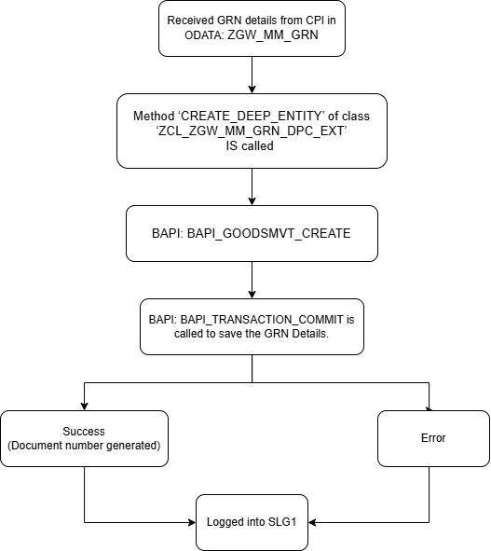

Processing Logic

ODATA ZGW_MM_GRN will be called
.
- Below Entities are created for mentioned ODATA:
- GM_HEADER -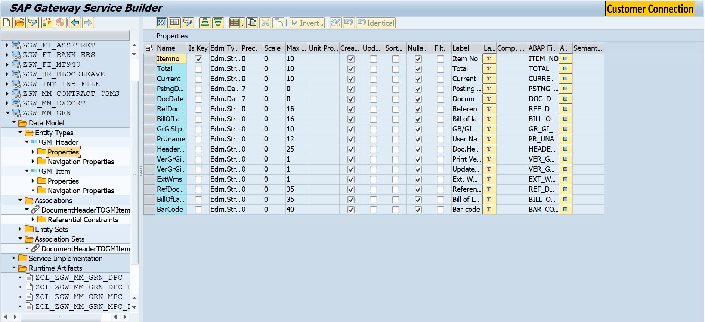

- GM_ITEM -
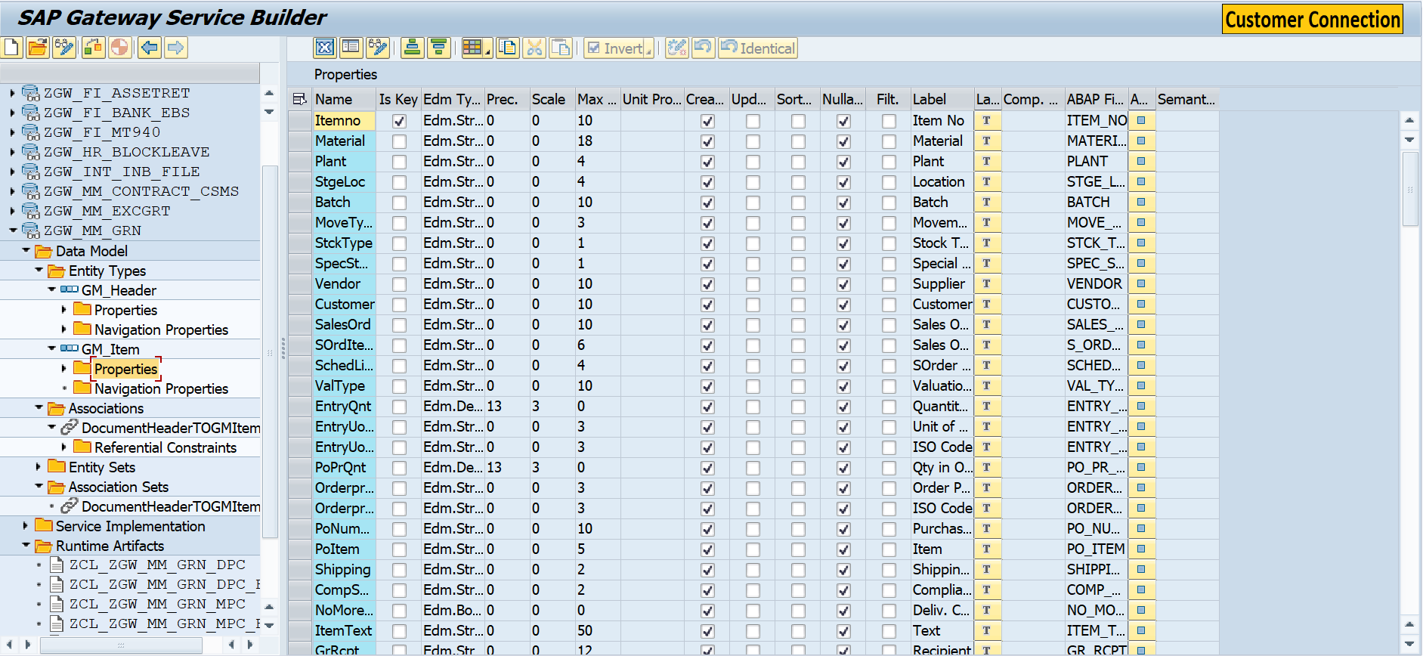

- Header Entity is mapped with Item Entity using Association: DocumentHeaderTOGMItem

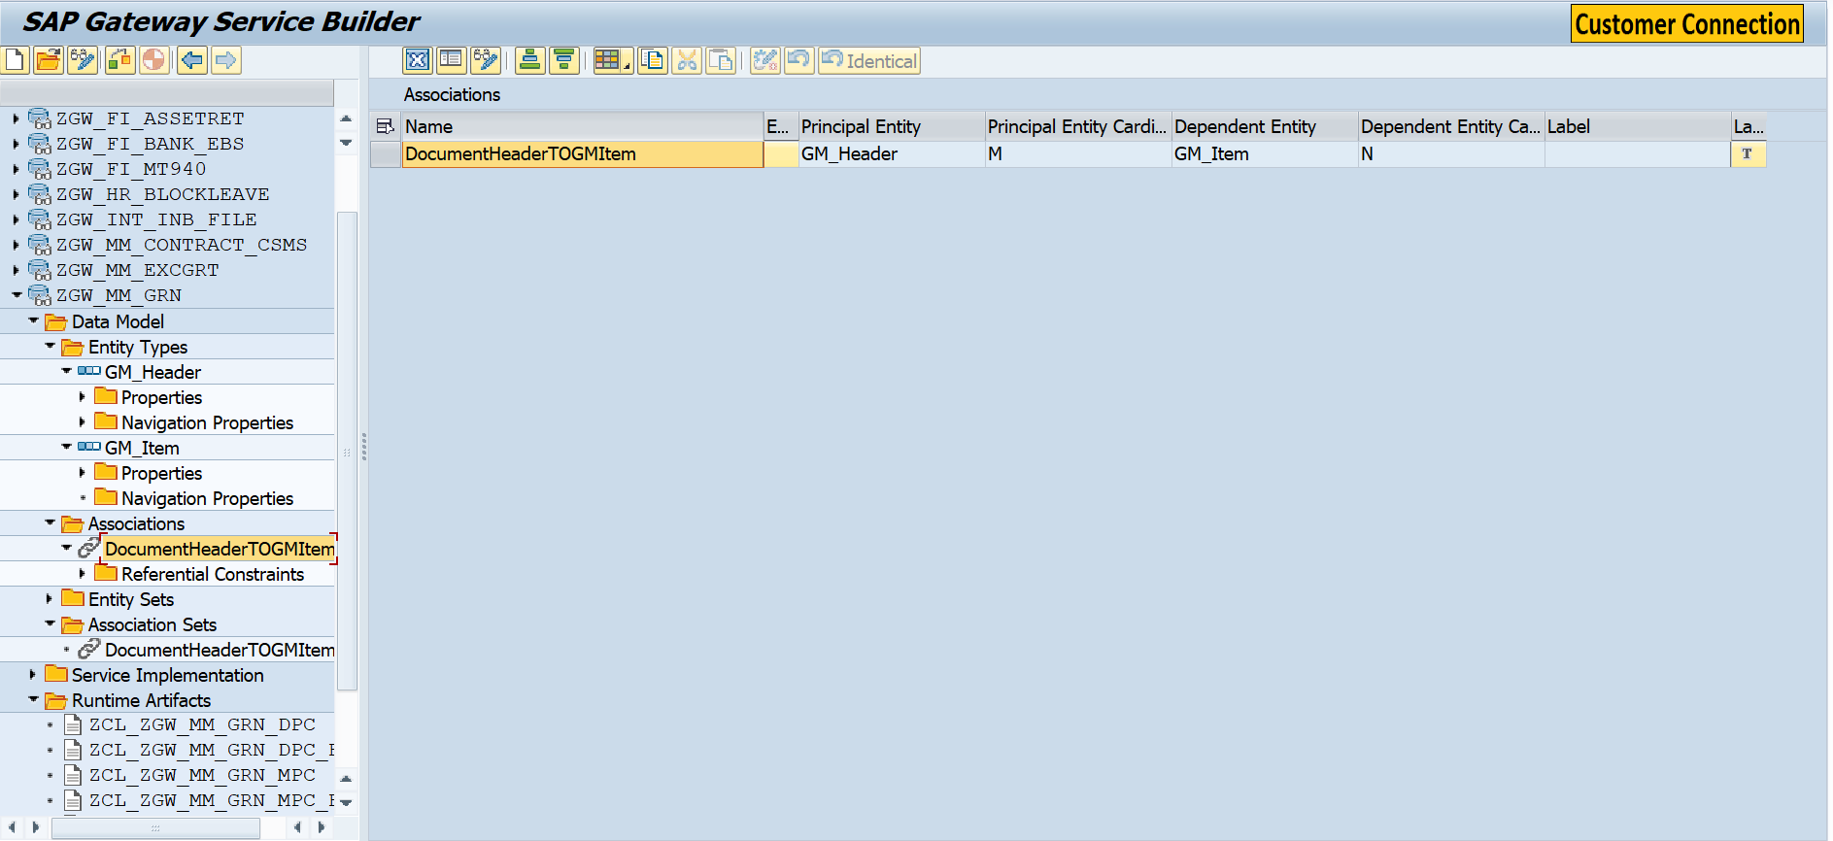

- Method ‘CREATE_DEEP_ENTITY’ of class ‘ZCL_ZGW_MM_GRN_DPC_EXT’ will be called by POST query from CPI.
- To create the contract document BAPI - BAPI_GOODSMVT_CREATE is used.
- BAPI_TRANSACTION_COMMIT is used to save the GRN detail in S4HANA.
- If Document is successfully created, then the success message along with document number will be recorded in SLG1.
- If error occurs while generating the document then the error message will be recorded in SLG1.

Validation
N/A

Mapping
N/A

Error Handling
N/A

Custom DDIC Objects
N/A

Custom CDS View Entity Details
N/A
Custom CDS entity Name
Primary View
Associated Views

BRF+ Design
N/A

Reusable Code
N/A

File Attributes
Same details mentioned in corresponding CPI Document.
File Type | Excel, ASCII, etc.?
Delimited / Fixed width | Comma, tab?
Header Record? | Provide layout
Footer Record? | Provide layout
Number of File Layouts and Description
File Layout(s) | Complete one per file layout (i.e., one for header records and one for detail records):

Messages
N/A
Message Class | Message ID | Message Text

Selection Text
N/A
Name | Description

Text Elements
N/A
Name | Text Description

Subroutines
N/A
Name | Description

Interface List Output

Field Details
N/A

Layout
N/A

Interface List Header & Footer
N/A

Application logs/Monitoring
N/A

Assumptions in Technical Design
N/A

Open Issues in Technical Design
N/A

Unit Test Results
N/A
Scenario # | Input Selection Criteria | Expected Result | Actual Test Pass/Fail
 |  |  | Choose an item.
 |  |  | Choose an item.
 |  |  | Choose an item.

Related Documentation
N/A

Template Version

Version | Status | Date | Version Created by | Reviewer | Approver | Comments
1.0 | Final | February 11, 2019 | Abhishek Nayak | Jagmeet Singh | Modak Gupta | Initial version created
2.0 | Final | Oct 18, 2023 | Ravish Ranka | Jagmeet Singh | Modak Gupta | Updates according to latest development guideline

